JR Paediatric Emergency Department

Assessing Children and Young People
Use the SBAR tool to complete an assessment, including:
- Relevant past medical history.
- Drug history (regular meds and last doses of Paracetamol + Ibuprofen – parents have often given these at home already).
- Allergies.
- Immunisation status - if babies are too young to be immunised, they will need to be separated from the other children in the department for their protection. Parental choice not to vaccinate their children should always be noted in the safeguarding tab to inform the health visiting team.
- Social services involvement – any previous or current involvement of social services or extra support around the family (named Social Worker, Early Help Hub, Disability Social Worker etc.)
- Don’t forget to weigh! All of our medication doses are calculated based on weight, so doing this at triage (as long as it is safe to do so) is very important.

All unwell children should have a full set of observations including a blood pressure (if you are able to get one) – keep in mind to look for the correct size blood pressure cuff, some children are much smaller/larger than expected for their age.

If struggling to obtain observations consider distraction techniques, if they don’t like the sats probe, try going onto a toe instead of a finger, and cover it up with a sock/shoe.

All children presenting with a head injury, or any abnormal neurology should have a full set of observations with BP + neurological observations – there is a separate tab for this on the left-hand side of the footprints which can be easily completed during triage.

Paediatric Early Warning Scores
We use the Paediatric Early Warning Score system (PEWS) to mirror NEWS2, we don’t use SEND - the system will automatically change the parameters for observations depending on the age of the child and generate a PEWS score accordingly.
PEWS can be easily added to your i-view on EPR and will give you an automatic warning if a patient’s PEWS score is triggering an alert (there is a guide on how to add this on EPR below).
Things to consider for raising a safeguarding flag (not an exhaustive list):
- Any injury of a non-mobile baby
- An injury that does not fit with the mechanism described.
- Burns
- Overdoses, self-harm, suicidal thoughts, or other mental health attendances
- Drug or alcohol intoxication.
- Dog bites – all dog bites must be referred in the safeguarding tab, discussed with social services (EDT if out of hours) and reported to 101 (this can now be completed online).
- Any unimmunised child (unless they are a baby too young to be vaccinated).
- Any genital injury.

Escalating from Assessment
- Elevated PEWS score
- Children who don’t have a raised PEWS but look clinically unwell.
- Safeguarding concerns
- Any significant injuries/severe pain – e.g., deformities
- Children who look well but have a significant mechanism of injury.

Specialty Teams
- Under 6 months – seen by Paediatric team. Paediatric SpR located in PED at most times, if not covered then covered by ward team.
- 6-12 months - seen by the ED doctors before midnight, if not then seen by Paeds
- GP referrals – seen directly by whichever specialty they’re referred to.
- Testicular pain – can be directly referred to Surgeons, discuss with Paeds NIC
- All other specialities (trauma, ENT, MaxFacs etc.) do not have specific paediatric teams
- Children over 13 with mental health presentations – seen by EDPS
- Children under 13 with mental health presentations – discussed with CAMHS

Treatments
- PGDs – Analgesia can be prescribed under a PGD only if you are competent and confident to do so. Please be mindful that you are giving the correct dose based on the child’s age and their weight
- Oral Fluid Challenge or “OFC” – Offered to children with D&V or poor oral intake. First line treatment is Dioralyte (please note, needs to be prescribed or given under PGD) but can be swapped to 50/50 apple juice and water if not tolerated. Consult the Oral Rehydration chart in triage room/nurse base for doses.
- Capillary BMs – Every child who presents with reduced intake, lethargy or D&V needs to have a blood sugar tested at triage and escalation to NIC if <3mmols.
- Urine Samples – Clean catch urine samples should be requested for children with fever, abdominal pain or testicular pain.
- Ametop/EMLA – These should be applied in triage either by PGD or if prescribed, using correct doses.
- Chest Assessments – If presenting with any form of breathing difficulty please escalate to a doctor to assess the patient for any immediate treatment needed

Frequent Presentations
- Fever – Will always need escalation if a baby <3 months old has a fever >38.0. Children with fevers for longer than 5 days will likely need investigation so require Ametop/EMLA.
- Breathing Difficulties – Any children with increased work of breathing, rapid respiratory rate, low saturations or additional airway sounds need escalation from triage for assessment by a doctor
- Abdo Pain – Children presenting with abdominal pain will need Ametop, BP measurement and a urine sample. Always escalate children with severe abdominal pain
- D&V/Reduced intake – Need a BM, BP and an OFC. If ongoing vomiting – consider escalation for Ondansetron prescription.
- Injuries – Escalation as required if any deformities. Adequate analgesia either under PGD or with prescription
- Foreign Body Ingestion – If history of coin ingestion consider use of metal detector. All other FB ingestions escalate for ?X-Ray
- Febrile Convulsions – Apply Ametop, ensure fever is controlled with anti-pyretics. Escalate if history of prolonged seizure or looks unwell.
- OD/DSH/MH – Consider where is safest for these young people to wait and if a room/1:1 is required

Common Medications and Calculations in PED
Doses for medications for children are always prescribed based on weight, using the BNFc for guidance.
Unless competent administering medications under PGD, please check all medications being given to children with a registered Children’s Nurse.
If struggling to get children to take their medication, please discuss with one of the Children’s Nurses
IV medications:
All IV medications administered to children must be weight-based, checked by two registered nurses and countersigned on EPR.
Medusa has a specific ‘Paediatric Intravenous Drugs’ link to follow
Use the BNFc to ensure correct doses are prescribed

Adding Paediatric Vital Signs to your EPR i-view:

- Click onto any patient’s i-view chart.
- Click ‘View’.
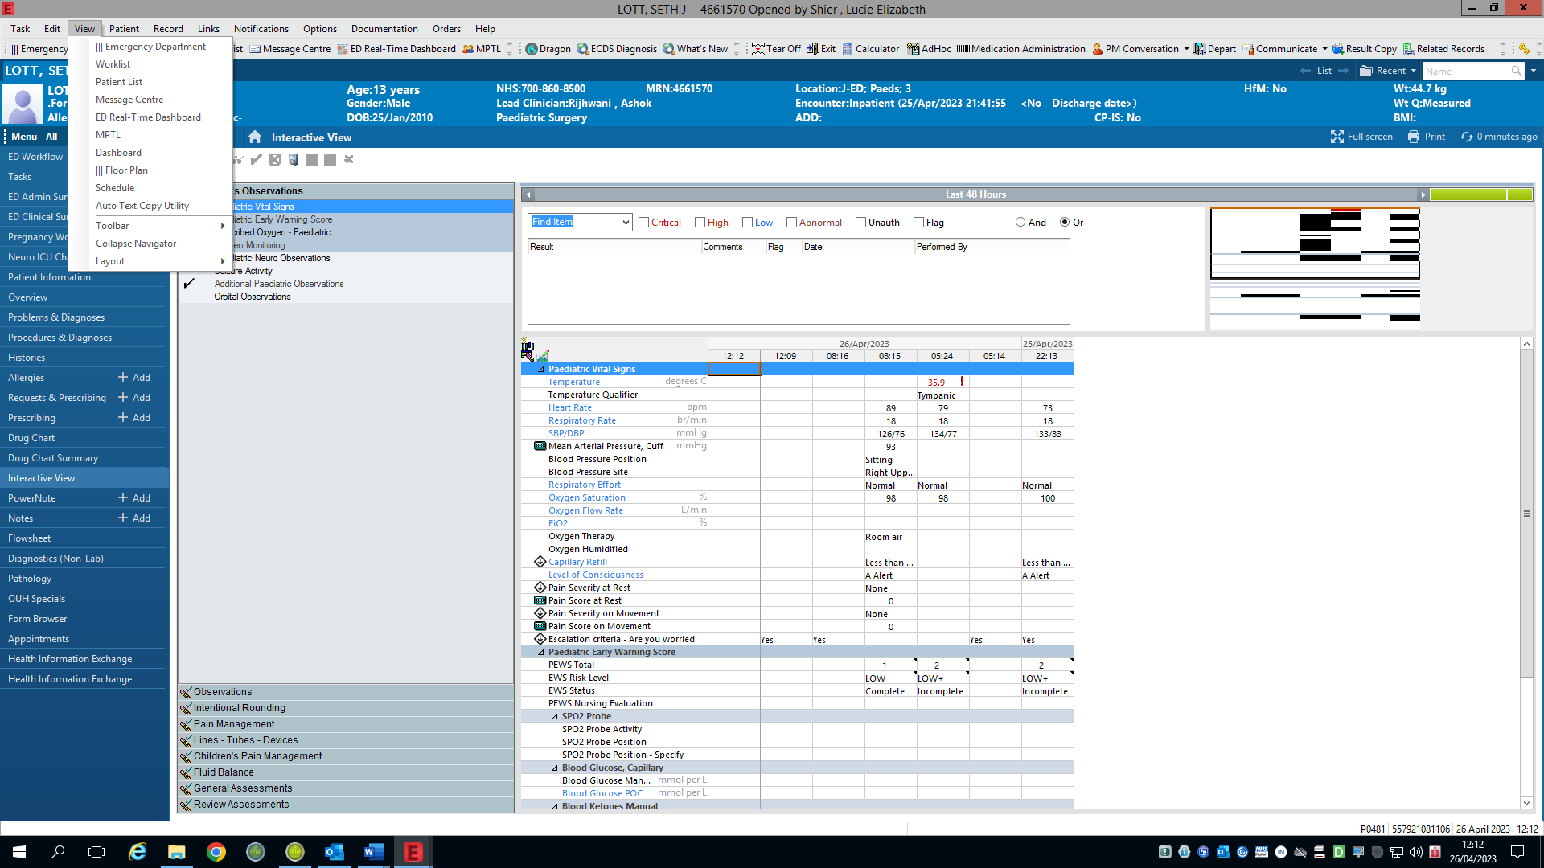

- Hover over ‘Layout’ and then click to ‘Navigator Bands’.
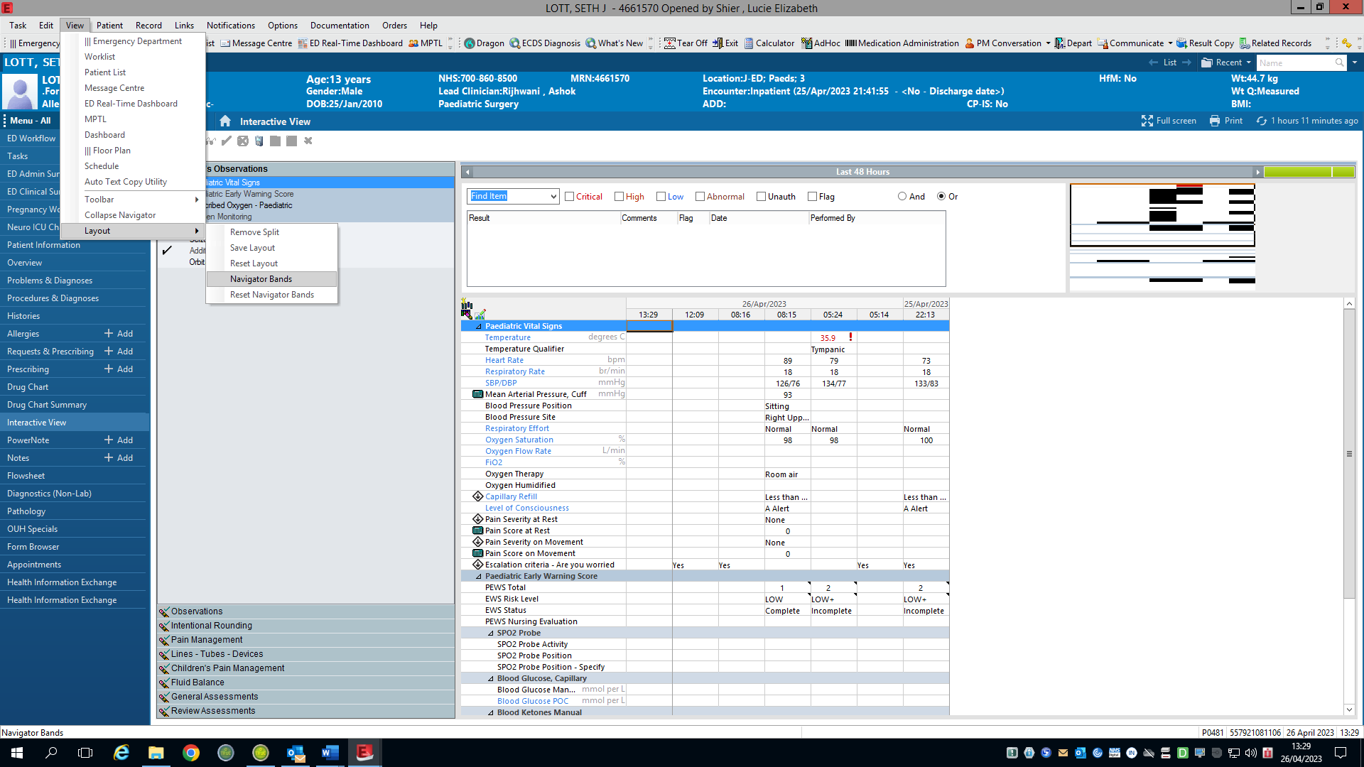

- Scroll to find ‘children’s systems assessment’, use the top arrow to move this tab into the ‘Current Document Types:’ box, then click ‘OK’.
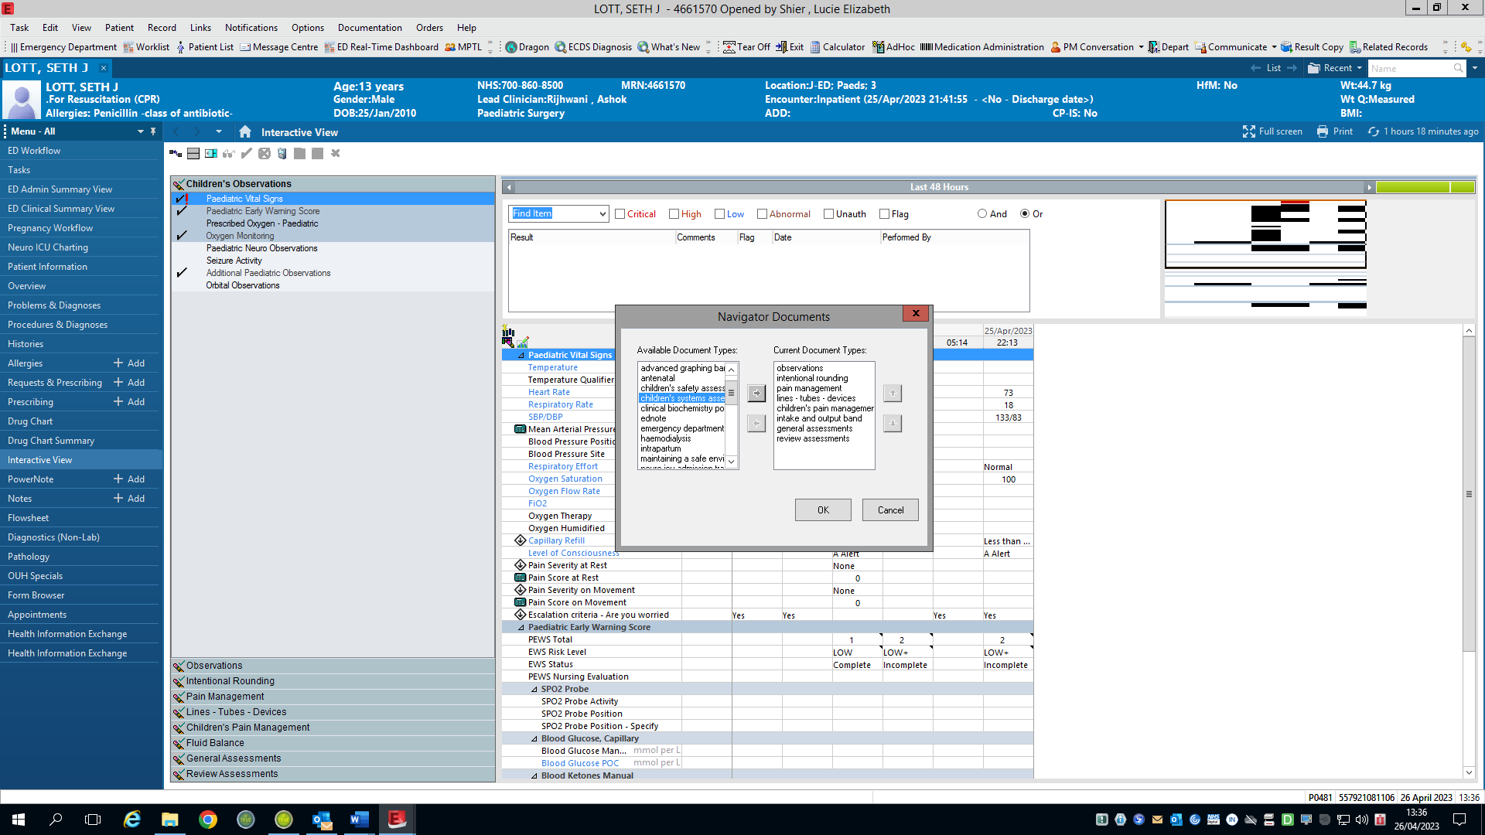

- The alert below will display automatically. Click ‘OK’, close i-view, refresh your EPR and ‘Children’s Observations’ will then appear on your i-view.
